Contents

Introduction 2

User 2

Create User 2

Login 2

Edit Profile 3

Logout 3

Recycle 4

Groups 4

Create Group 4

Join Group 5

My Groups 6

Edit Group Profile 6

Joined Groups 7

Recycling Locations 7

Contest 7

Create Contest 7

View Contests 9

View Contest Activity 10

Dashboard 11

View Dashboard 11

Filter Dashboard By Group 14

Filter Dashboard By User 14

s

# Introduction

The ECOSustainabilityEfforts application empowers users, groups and communities with the ability to be ECO sensitive and friendly.

The application works seamlessly on any internet enabled device of any size.

The application allows any user to create group, of which they become group owners. As group owners, they have the ability to create contests by which users log recycling activities in order to win some sort of prize, be it tangible or intangible.

# User

## Create User

In order to begin participating in your group you need to create an account. This is easily down by accessing the home page at, <http://ses-dev.cis.fiu.edu> and scrolling down and locating the, “Create Account”, panel (See Figure 1A). Once you have located the panel, fill in the required user account information and click “Create Account”.

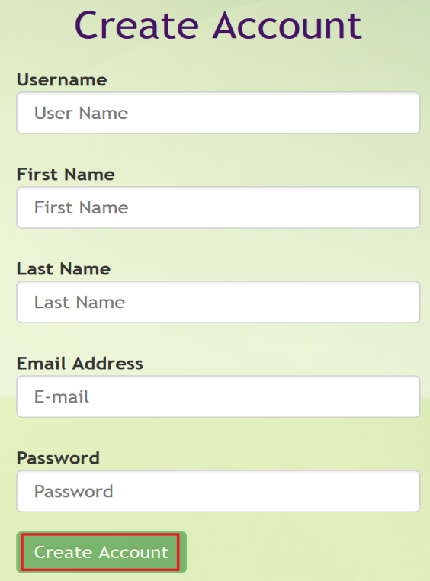

**Figure 1A:** Create Account

## Login

Once you have created a new account, you will now be able to login using the credentials you have provided when creating your account. Simply access the home page at, <http://ses-dev.cis.fiu.edu> and at the top right (See Figure 2A) enter your credentials and hit “Sign in”. If successful, you should be presented with a User Home page that includes dashboard information regarding overall groups and users, otherwise you will receive an error message.



**Figure 2A:** Login

## Edit Profile

In order to edit your profile you need to be logged in and then access the “User” menu item, and then the “Edit Profile” sub-menu item (See Figure 3A). You will now see a summary of the existing profile information, which you can change as need be and then hit “Save” button to confirm your updates (See Figure 3B).

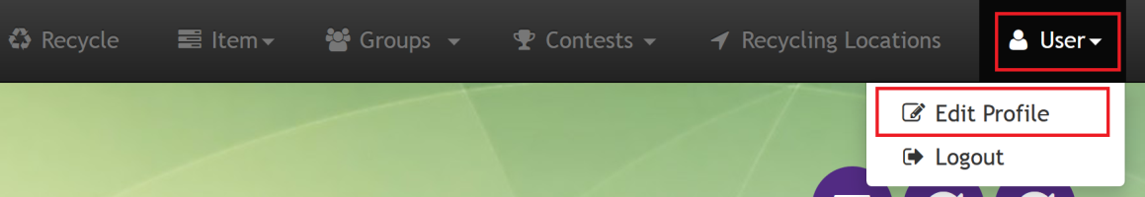

**Figure 3A:** Edit Profile Menu Path

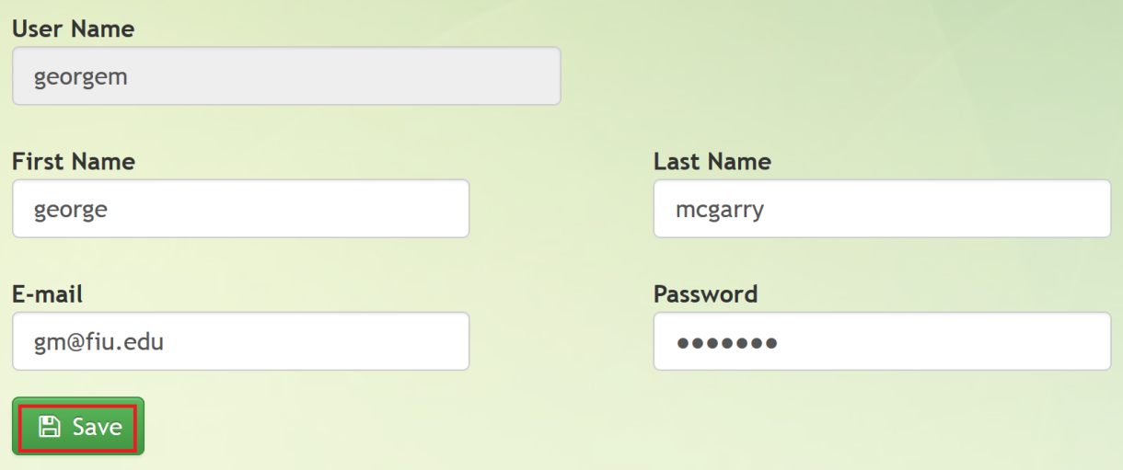

**Figure 3B:** Edit Profile

## Logout

If you are already logged in and wish to logout, acces the “User” menu item, then the “Logout” menu sub-item (see Figure 4A).

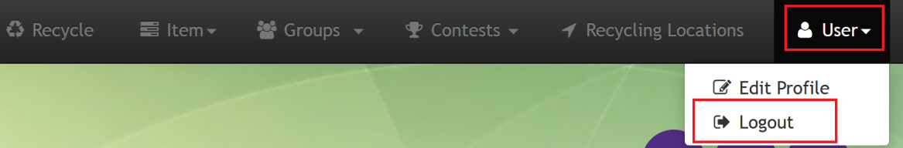

**Figure 4A:** Logout

## Recycle

Recycle is the screen you will be using to recycle an actual item. It will log your recycling action for a particular group and a particular item, both of your choosing. First, Login and click “Recycle” on the menu (See Figure 9A), to begin recycling. Then, select the group you wish this action to be associated with and then select the item you are recycling. Lastly, you enter the quantity of this item you are recycling and click “Create Recycling Action” (See Figure 9B).



**Figure 9A:** Recycle Menu Path

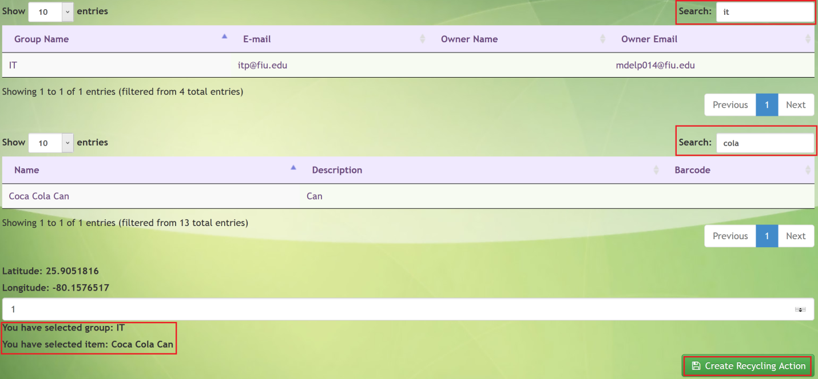

**Figure 9B:** Recycle

# Groups

## Create Group

In order to begin creating your own community to reward for recycling efforts, you need to create a group. You need to access the “Group” menu item, and then the “Create Group” sub-menu item (See Figure 5A). Enter all the required information and fill in any as much of the non-required information and then click “Save” (See Figure 5B). Now you can start inviting users to join your group and begin participating in your group’s contests.

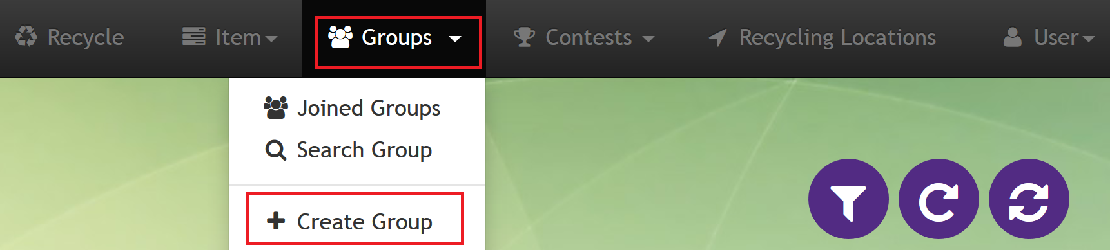

**Figure 5A:** Create Group Menu Path

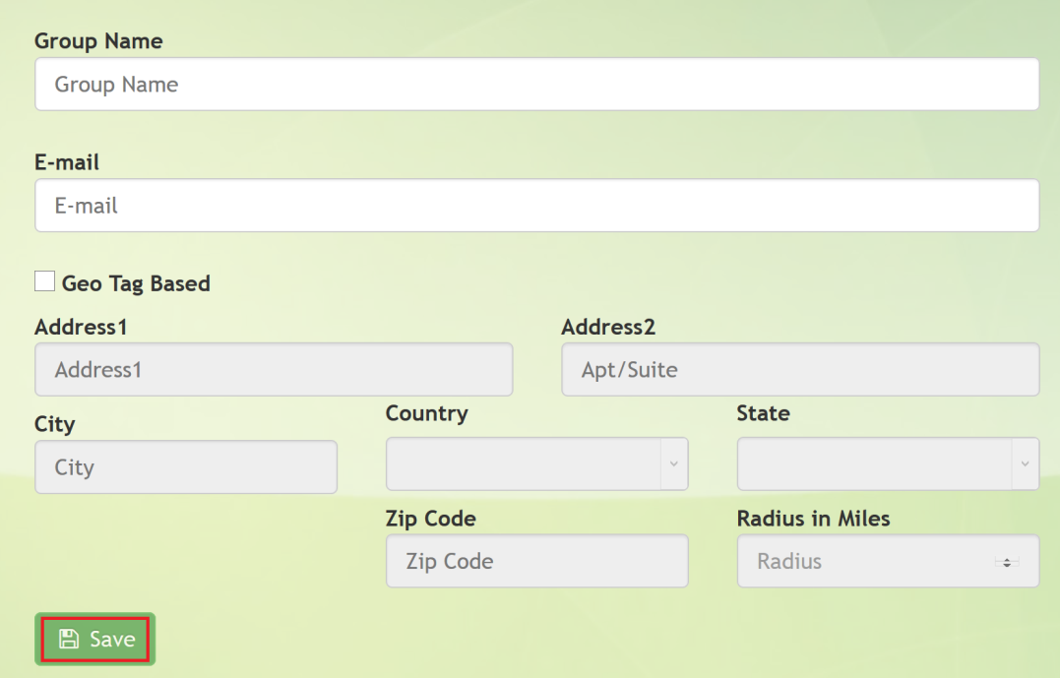

**Figure 5B:** Create Group

## Join Group

Say an organization, group or corporation asked you to participate on behalf their group. All you have to do is click on the “Group” menu item, then the “Search Group” sub-menu item (See Figure 6A). Then, search for a group by group name or e-mail (among other search items), select the group and click “Join” (See Figure 6B). Once the group administrator receives your response he will accept you, and you are in!

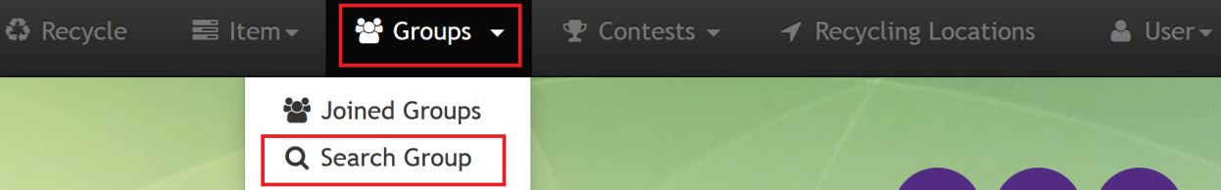

**Figure 6A:** Join Group Menu Path

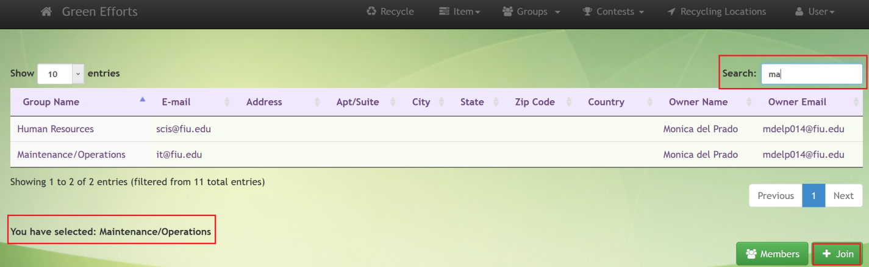

**Figure 6B:** Join Group

# My Groups

## Edit Group Profile

In order to edit your group profile you need to be logged in and then access the “Groups” menu item, and then the “My Groups” sub-menu item (See Figure 7A). You will now have a listing of all Groups you own, select on and click “Edit” (See Figure 7B). You will now see a summary of the existing profile information, which you can change as need be and then hit “Save” button to confirm your updates (See Figure 7C).

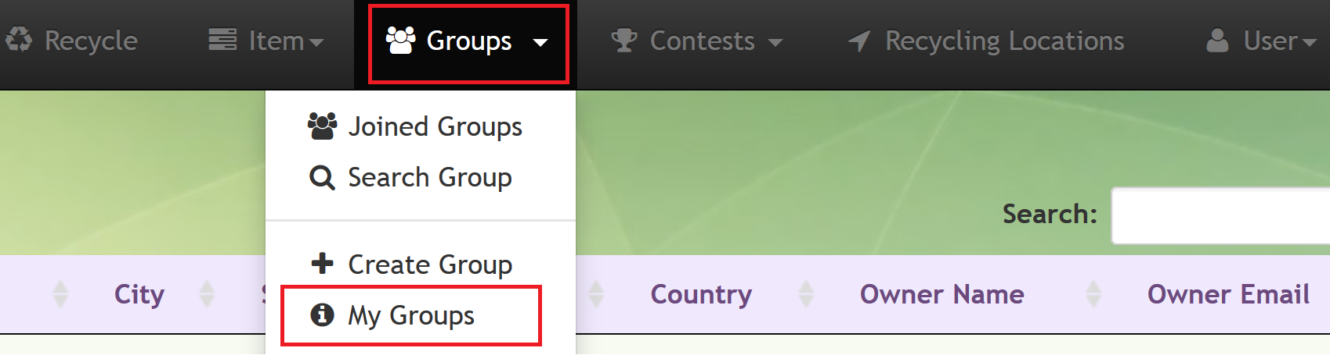

**Figure 7A:** My Groups Menu Path

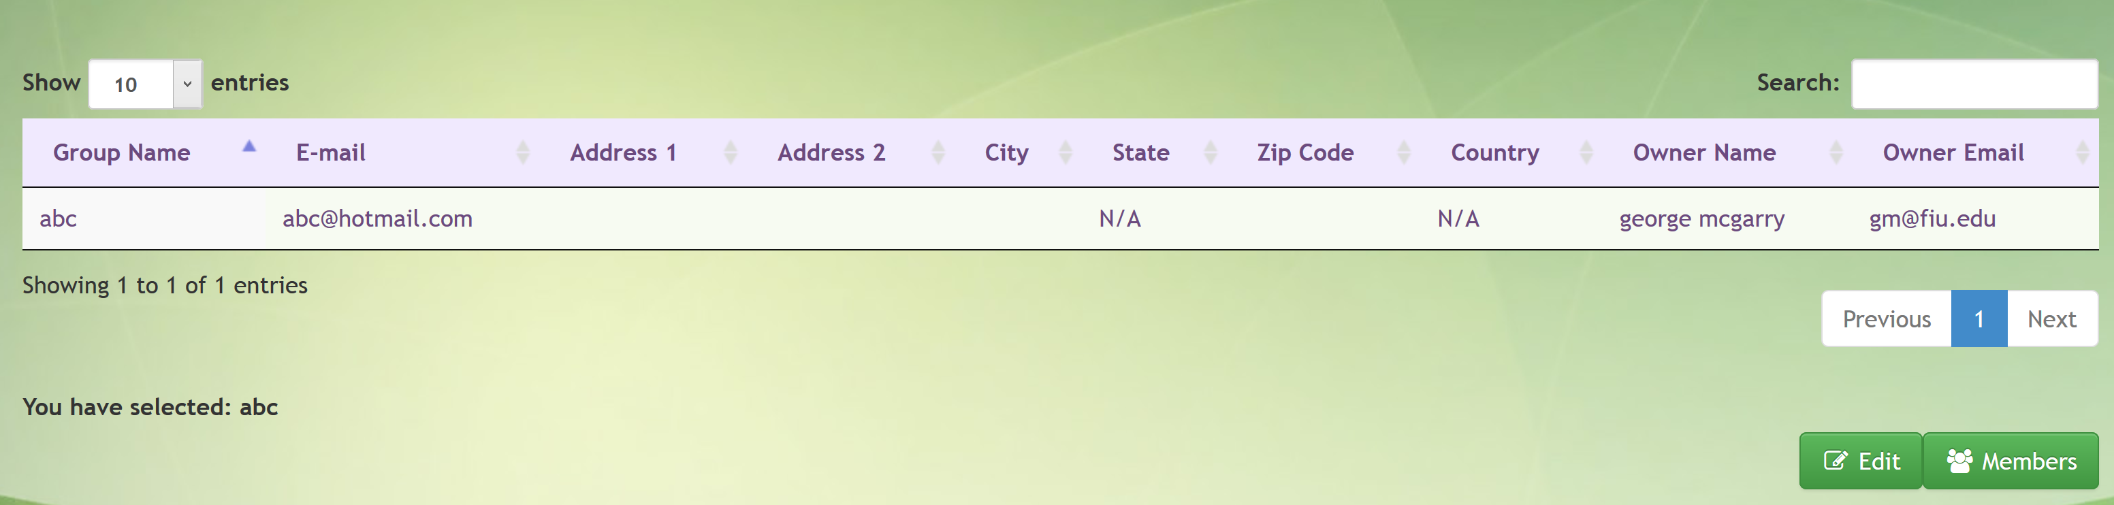

**Figure 7B:** My Groups Selection Screen



**Figure 7C:** My Groups Edit Profile

# Joined Groups

# Recycling Locations

So you want to see any recycling locations that may be near your current location, be it you are using a phone, table or desktop browser. Simply login and click on “Recycling Locations” (See Figure 8A), you may be prompted to allow us to view your location (which is kept privately), and recycling location points will be displayed. You can click on a point and get the address, description and contact number.



**Figure 8A:** Recycling Locations Menu path

# Contest

## Create Contest

To create a contest, select Contest in the dropdown menu Contest navigation bar

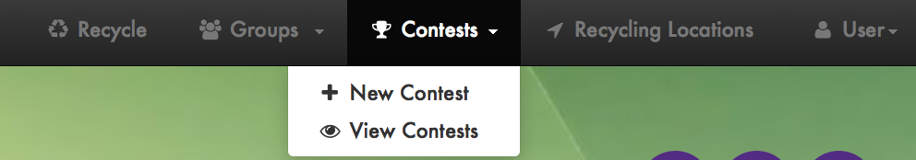

**Figure 8A:** New Contest Menu Path

The following form will appear:

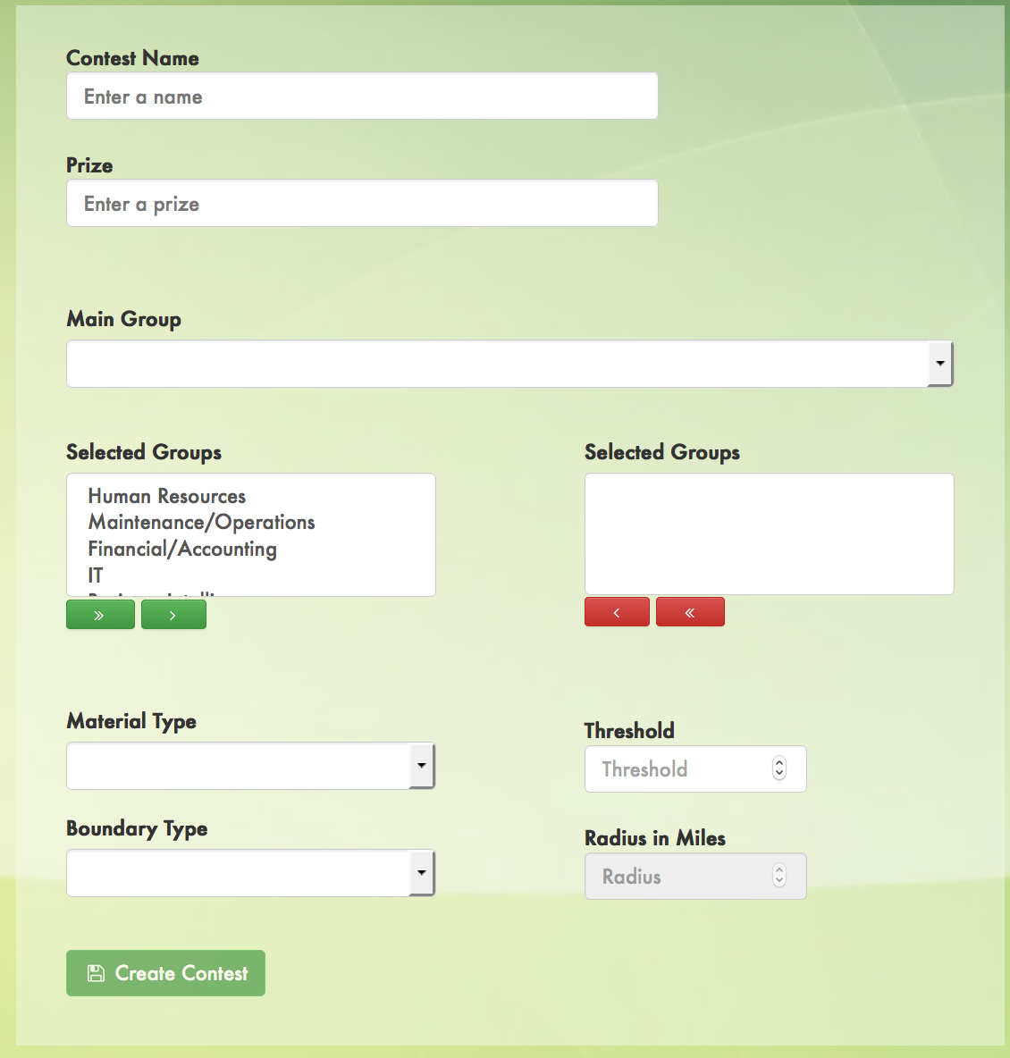

**Figure 8B:** New Contest Form

Only group owners and authorized users can create contests for a group (main group). Other groups can be added optionally to the group.

The contest would have the following fields:

Name (required): assign a name to the contest

Prize (optional): states prize for contest if any

Main group (required): main group for which he contest would be in place

Selected groups (optional): additional groups that can be added

Material type (required): base material that needs that counts toward the contest.

Threshold (required): amount of the material to win the contest

Boundary (optional): None or restricted by location (see radius)

Radius (optional, required if boundary Location is selected): if boundary Location is selected, maximum radius where items can be recycled to count toward the contest.

## View Contests

To view active and finished contests, select View Contest in the dropdown menu Contest navigation bar

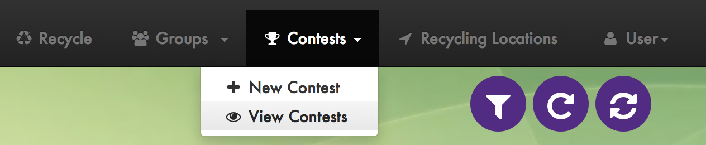

**Figure 8C:** View Contest Menu Path

A screen similar to the following will appear. It will list Contest Name, Contest prize, Material, Threshold, Boundary, Radius, Active/Finished status

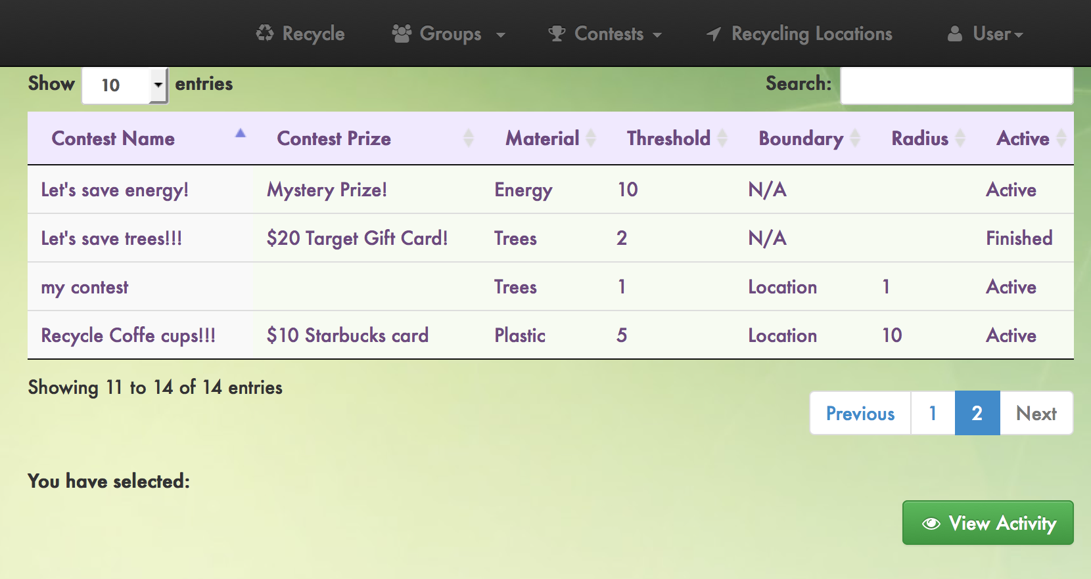

**Figure 8D:** View Contest

## View Contest Activity

To view the activity related to a specific contest. Select on the contests listed in View Contest and click View Activity



**Figure 8E:** Contest Selection

The following screen will appear displaying users that participated in the contest and the total items (points) that have recycled. If the contest finished, it will display the winner of the contest.

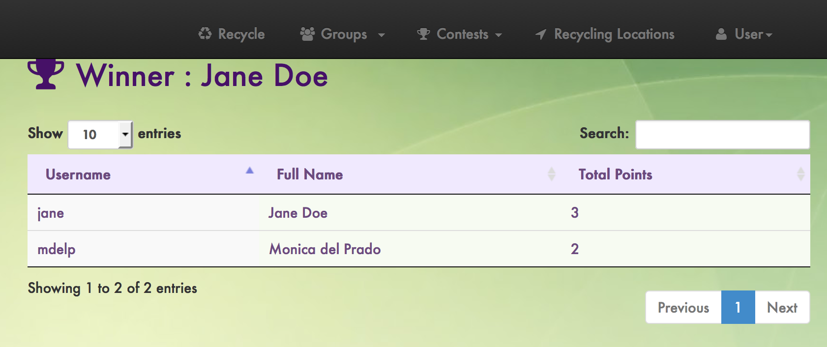

**Figure 8F:** Contest Activity

# Dashboard

## View Dashboard

The dashboard appears on the User Home once the user has logged in.

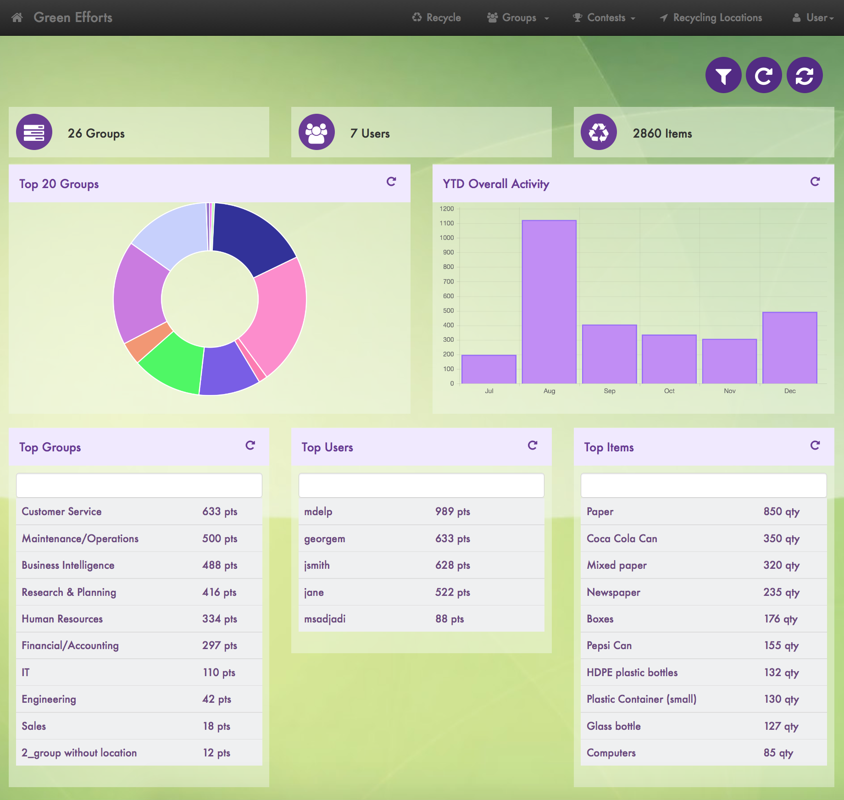

F

E

D

A

B

C

5

8

7

6

4

3

2

1

**Figure 9A:** Main dashboard

1. Total groups
2. Total users
3. Total items recycled
4. Top 20 groups activity
5. Last 12 months activity of all groups
6. Top 10 Groups
7. Top 10 users
8. Top 10 items

The following options can be applied to the dashboard

1. Filter by group and user

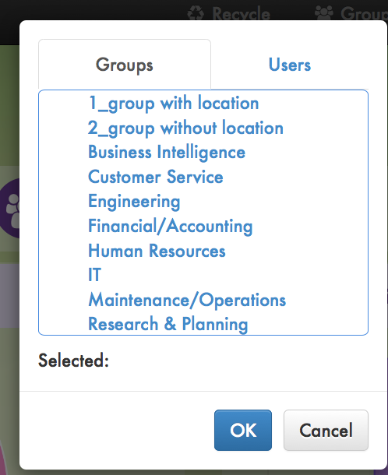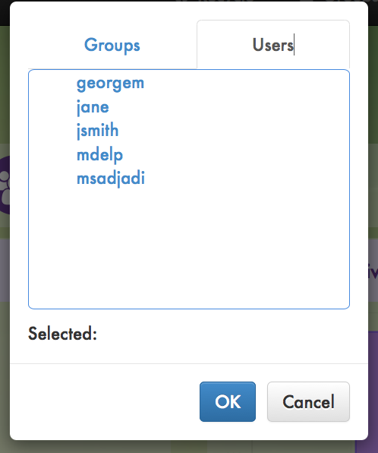

**Figure 9B:** Filter menus

1. Refresh Dashboard: refresh current information displayed
2. Reload Dashboard: Reload main dashboard
3. Search by group name:

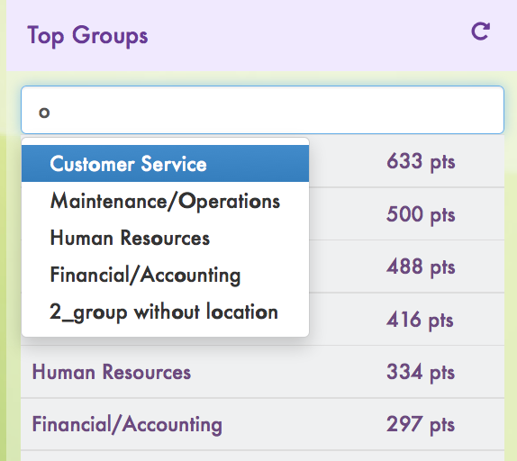

**Figure 9C:** Search by group

1. Search by username:

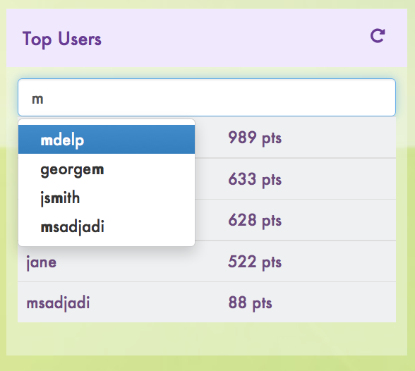

**Figure 9D:** Search by username

1. Search by items recycled:

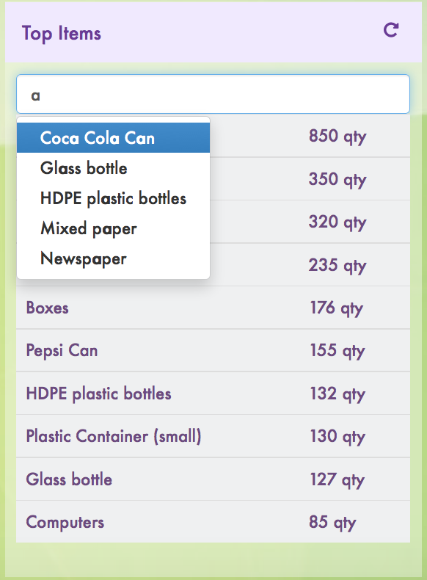

**Figure 9E:** Search by items

## Filter Dashboard By Group

When the dashboard is filtered by group name, the information will be only related t that group. The same options that can be applied to the main dashboard are available to the filtered dashboard

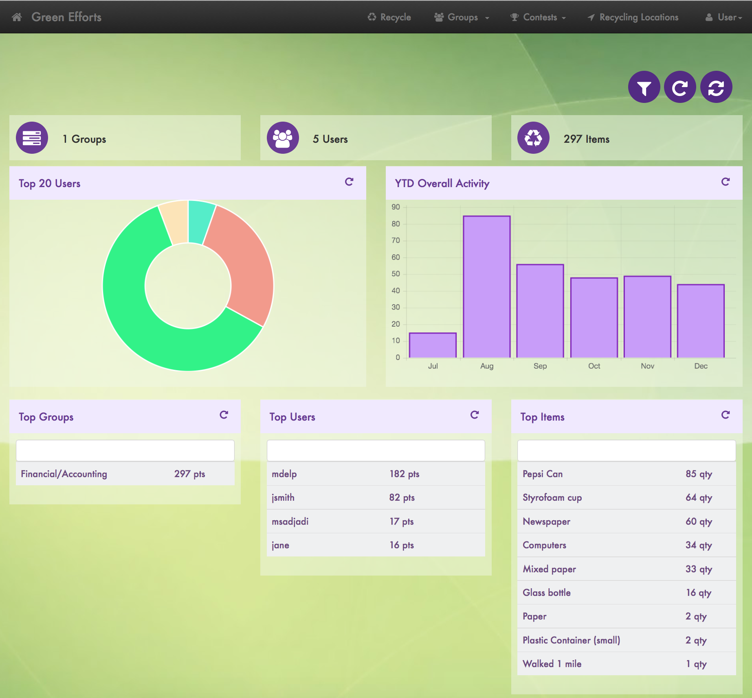

4

**Figure 9F:** Dashboard filtered by group name

Note that the Top 20 Groups chart will become Top 20 users that belong to that group.

## Filter Dashboard By User

When the dashboard is filtered by group name, the information will be only related to that user. The same options that can be applied to the main dashboard are available to the filtered dashboard.

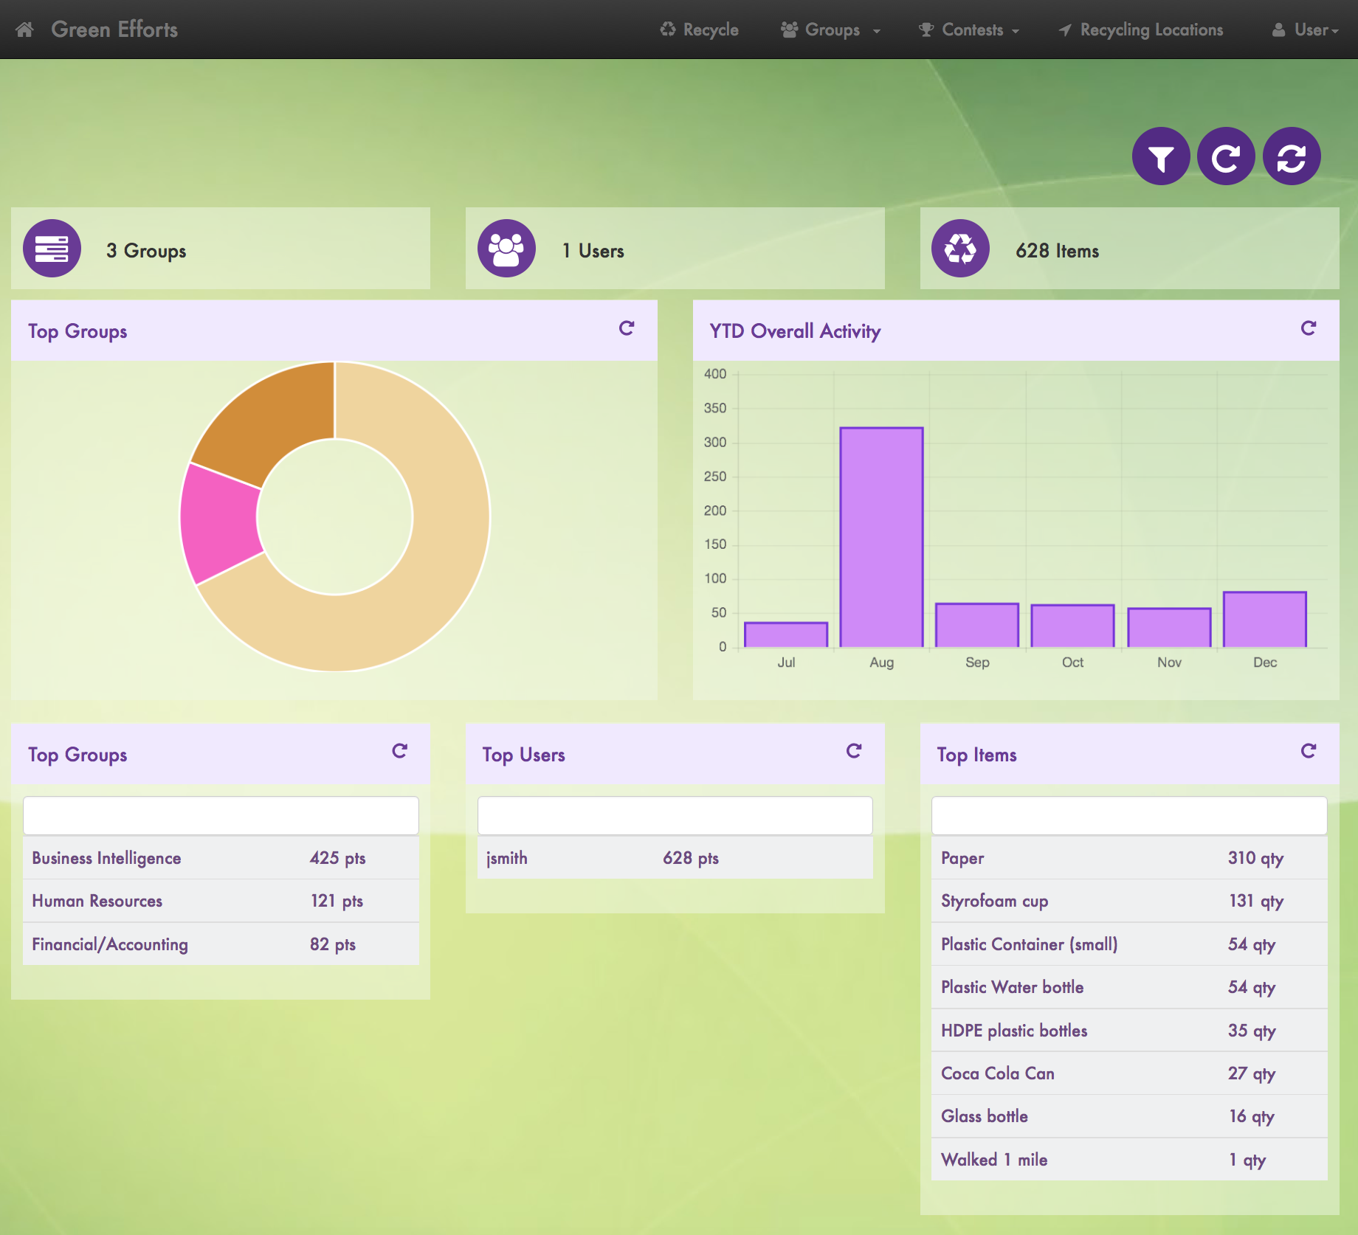

**Figure 9F:** Dashboard filtered by username